**Assignment 3**

**Objective** – Power BI Desktop, Cloud Service and End to End Workflow

**Use Case** – Import list of the richest people using Query Editor

**Source** – Richest people

**Analytics** – The raw data - your task is to transform it into something more presentable.

**Report/Dashboard** – Richest people

**Create a new Power BI report, and load in the data**

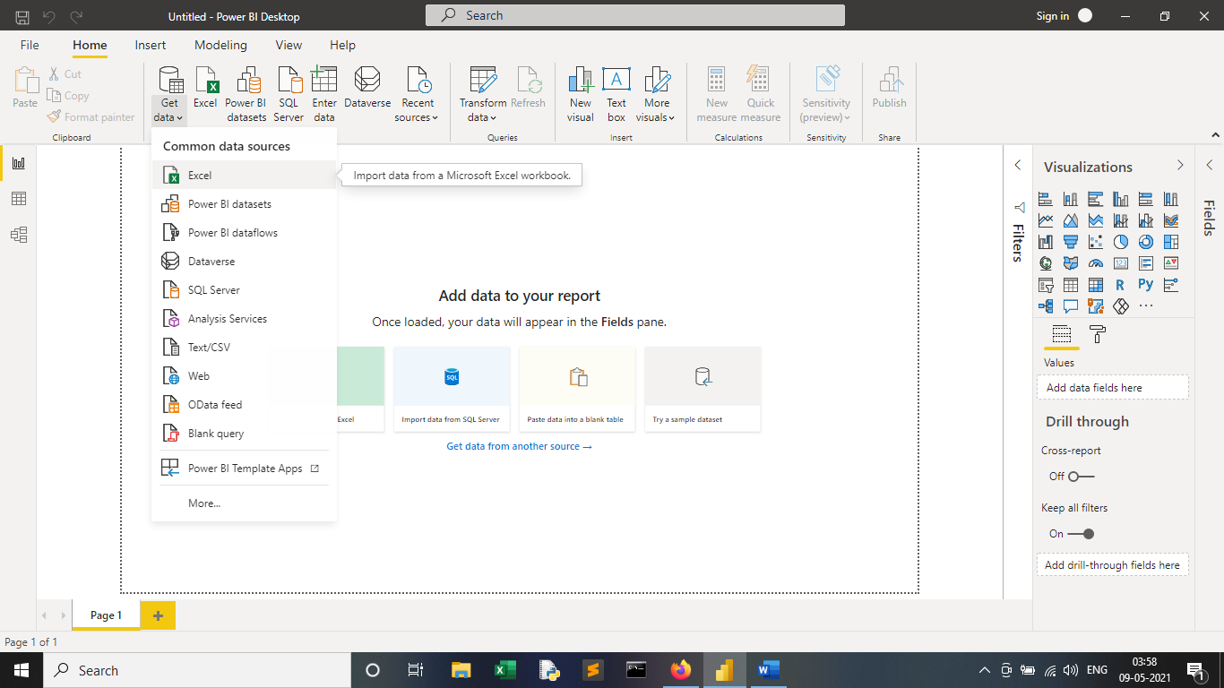

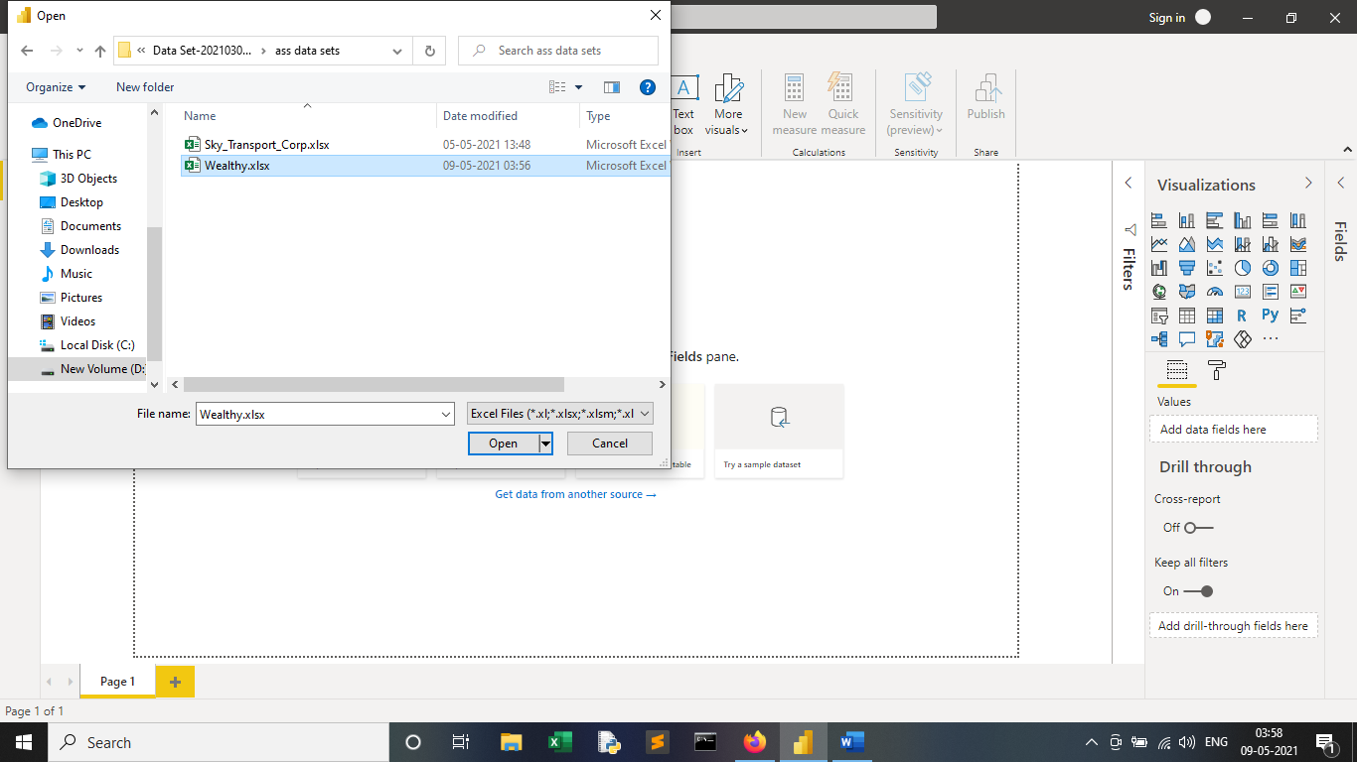

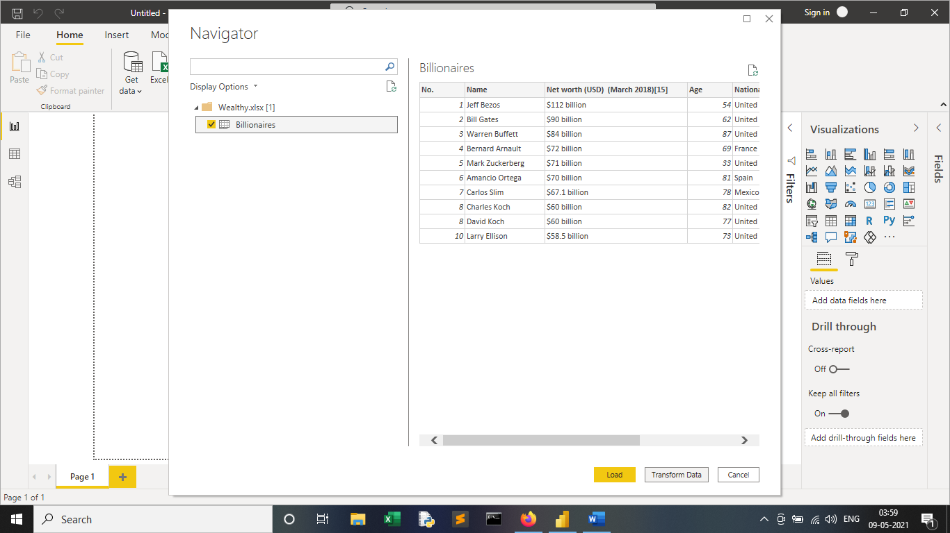

**Some columns have been renamed, while each person's wealth (in billions of dollars) has been extracted**

1. Replace the word billion with an empty string.

2. Replace the $ symbol with an empty string.

3. Convert the resulting column to a whole number.

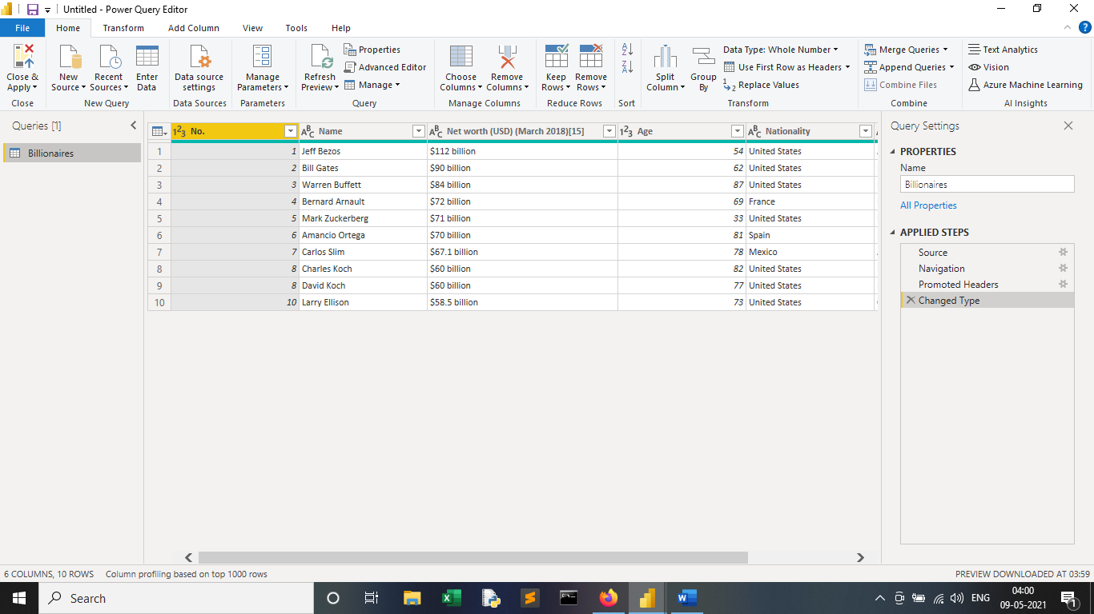

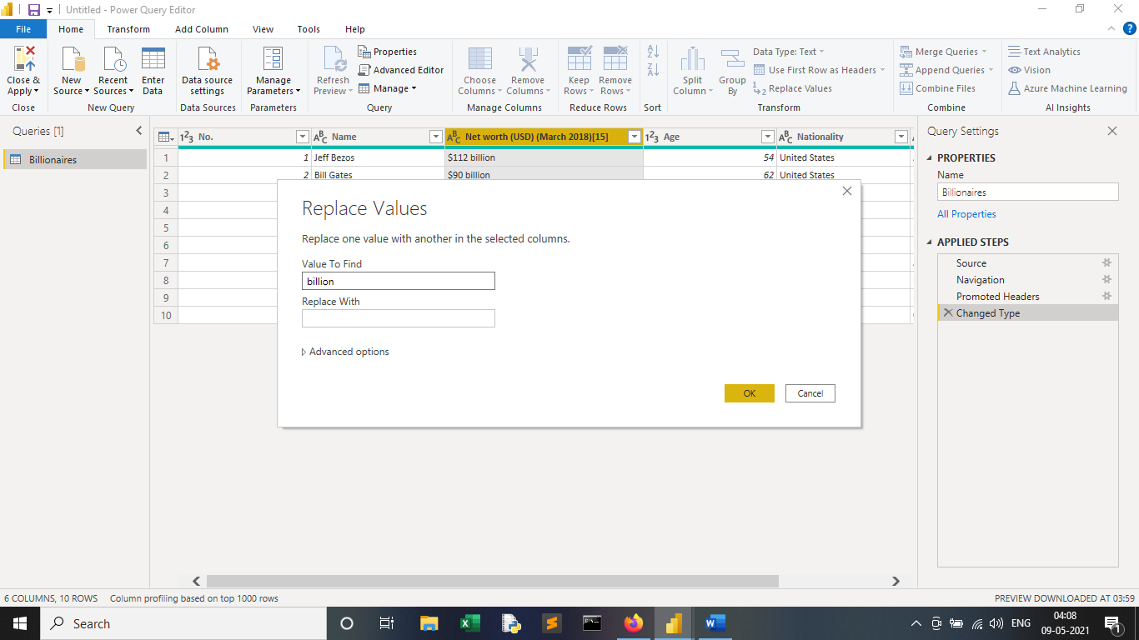

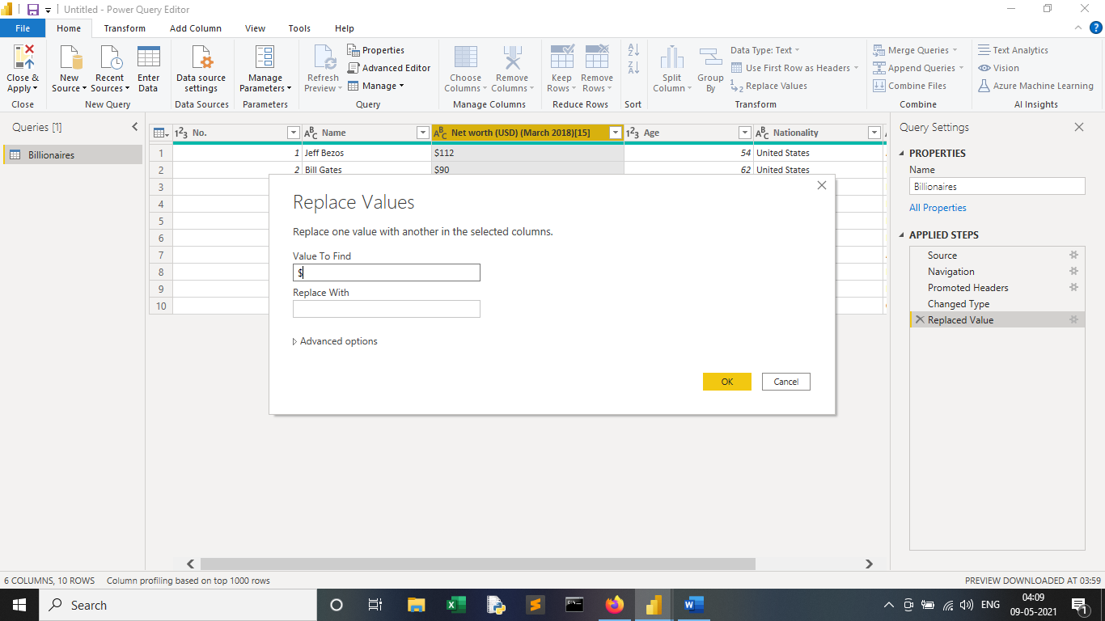

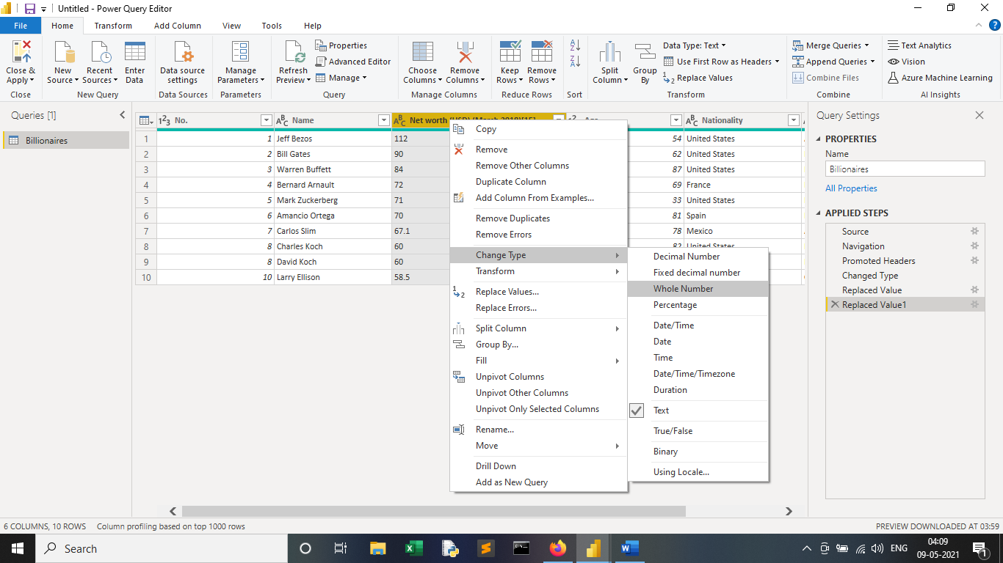

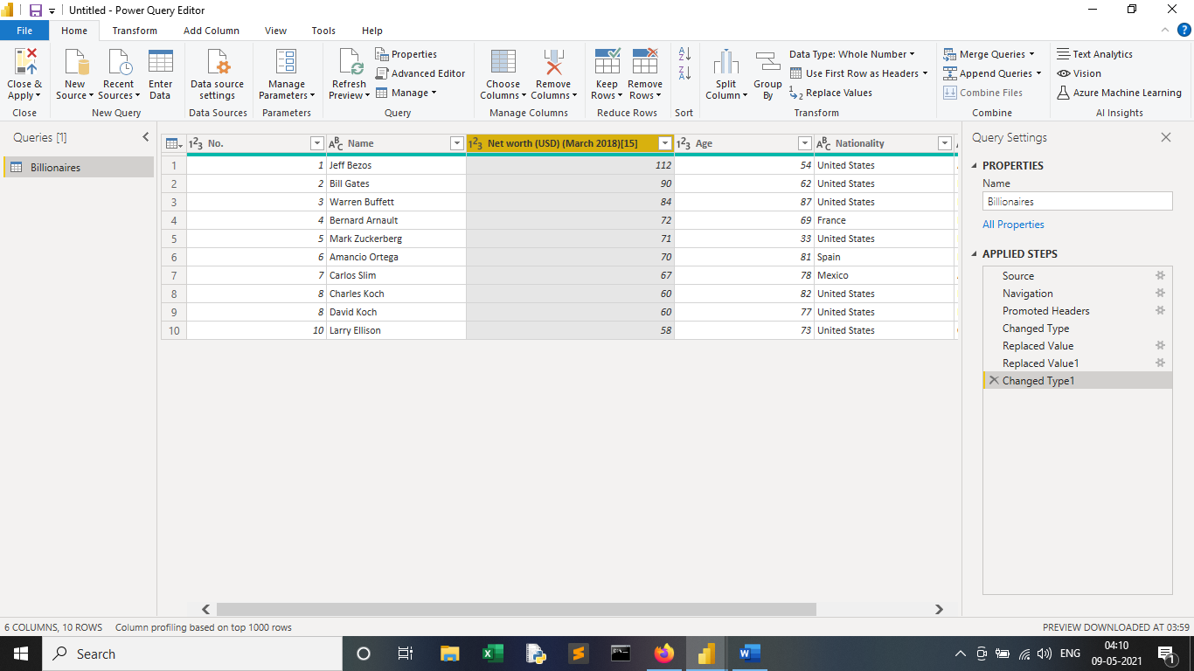

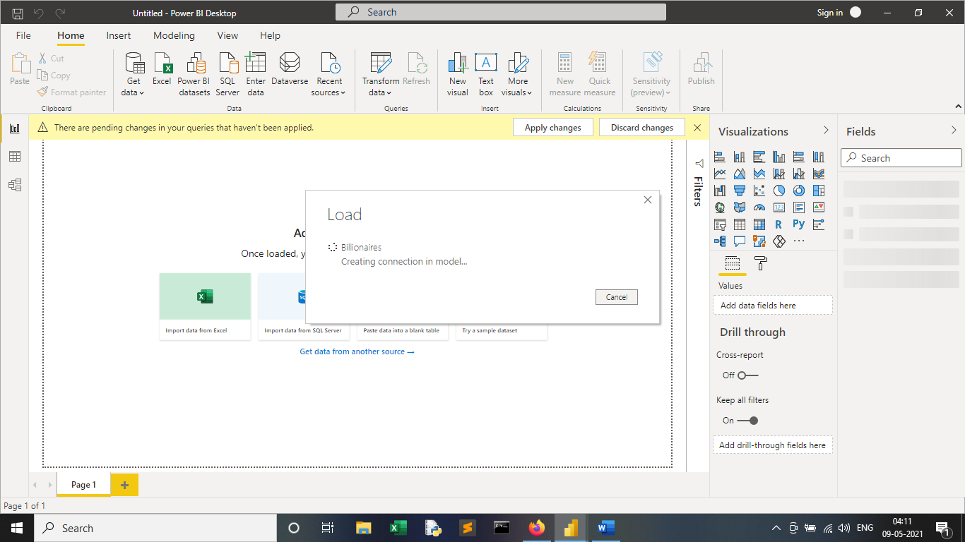

**Create a chart just to prove that the billions really are being treated as numbers.**

